Retro-Modern Rock Band Dagger Down Releases Inaugural Album
Singer, songwriter and guitarist Lawrence Fothe returns to music after 10-year hiatus

September 14, 2018 (NEW ORLEANS, La.)— Singer, songwriter and guitarist Lawrence Fothe has returned to the music scene after a 10-year hiatus with the creation of retro-modern rock band, Dagger Down and launch of the group’s inaugural album, Dagger Down. The name alludes to punctuating the presence of music in specific times and places at any given moment. Dagger Down is available now on iTunes, Spotify, Apple Music and Soundcloud, and will be available for purchase on 12” vinyl at www.daggerdown.com.
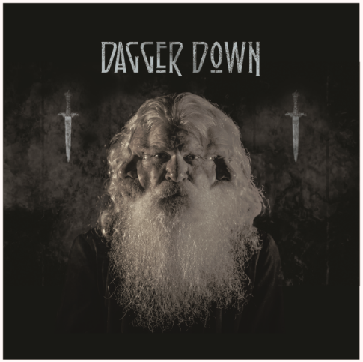
Dagger Down

Produced by:
Rick G. Nelson

Engineered by:
Paul McDonald

Recorded at:
Marigny Studios

Artwork by:
Ruby Rendrag

Photography by:
Zack Smith

Selections written by:
Lawrence Fothe

Born and raised in New Orleans, Louisiana, Lawrence Fothe developed a love for the arts at an early age. He wrote and published poetry in literary journals and was an avid oil and acrylic painter. His love for the arts grew into love of music; by age 16, Fothe was playing guitar and drums with many local bands including Formula Explosion, Pleasure, Omega and H. Royd & Lowlife among others.

Fothe moved from his hometown of New Orleans to Picayune, Mississippi in 2008 to care for his aging parents, who both passed last year. While in Picayune, Fothe placed his music on hold, but continued to excel in painting, hosting solo exhibitions and winning industry awards. In early 2018, Fothe’s strong love for music motivated him to re-enter the music scene and pursue his dreams of forming Dagger Down.

In addition to Lawrence Fothe on guitar and vocals, Dagger Down contributing musicians include Paul McDonald (guitar, tambourine); Rick Nelson (Bass, strings, keys, guitar); Jonathan Arceneaux (drums); Dennis Hyde (guitar); and Daniel Crane (percussion).

“Our inaugural album places all human emotions, trials, heartache, joy and love in settings all of us can relate to, along with a touch of humor—all of which are simply testaments to life and living,” Said Fothe. “It’s a sharing of values that I wish for others to listen to and immerse themselves in the worlds musically created.”

Fothe’s creation of Dagger Down represents a culmination of sound, emotion, thought and philosophy encompassing everything meaningful about being human. The freshman album stems from the desire to bring entertainment and joy to others in a live music setting and draws inspiration from artists including Jimi Hendrix, Led Zeppelin, ELO, Tool, Sound Garden, Jimmy Page and ZZ Top.

For more information on Dagger Down and upcoming tour dates, visit www.DaggerDown.net.

###

